

Faculty of Engineering and Technology
Department of Electronics and Communication Engineering
Jain Global Campus, Kanakapura Taluk - 562112
Ramanagara District, Karnataka, India

2017-2021

A Project Report on

“IoT Based Smart Shopping Cart”

Submitted in partial fulfilment for the award of the degree of

Bachelor of Technology
in
ELECTRONICS AND COMMUNICATION ENGINEERING

Submitted by

AKHILESH SHINDHE
17BTLEC002

VIJAYKUMAR S RAYANAGOUDAR
17BTLEC008

RAHUL RAO SHINDE K
17BTLEC012

ANISH KUMAR SINGH
17BTREC017

Under the guidance of

Prof.Basavaraj.H
Assistant Professor
Department of Electronics and Communication Engineering
Faculty of Engineering & Technology
JAIN(DEEMED-TO-BE UNIVERSITY)

Faculty of Engineering & Technology
Department of Electronics & Communication Engineering
Jain Global campus
Kanakapura Taluk - 562112
Ramanagara District
Karnataka, India
CERTIFICATE

This is to certify that the project worktitled “IoT Based Smart Shopping Cart” is carried out by AKHILESH SHINDHE(17BTLEC002),VIJAYKUMAR S RAYANAGOUDAR (17BTLEC008),RAHUL RAO SHINDE K(17BTLEC012),ANISH KUMAR SINGH (17BTLEC017) are bonafide students of Bachelor of Technology at the Faculty of Engineering & Technology, JAIN DEEMED-TO-BE UNIVERSITY, Bengaluru in partial fulfillment for the award of degree in Bachelor of Technology in Electronics and Communication Engineering, during the year 2020-2021.

Prof.Basavaraj.H | Dr. R. Sukumar | Dr. Hariprasad S.A
Assistant Professor  Dept. of ECE,  Faculty of Engineering & Technology,  JAIN DEEMED-TO-BE UNIVERSITY  Date: | Head of the Department,  Electronics and Communication,  Faculty of Engineering & Technology,  JAIN DEEMED-TO-BE UNIVERSITY  Date: | Director,  Faculty of Engineering & Technology,  JAIN DEEMED-TO-BE UNIVERSITY  Date:

Name of the Examiner Signature of Examiner
1.

2.
<
DECLARATION
We AKHILESH SHINDHE(17BTLEC002), VIJAYKUMAR S RAYANAGOUDAR (17BTLEC008), RAHUL RAO SHINDE K(17BTLEC012), ANISH KUMAR SINGH (17BTLEC017) are student’s of eighth semester B.Tech in Electronics and Communication Engineering, at Faculty of Engineering & Technology, JAIN DEEMED-TO-BE UNIVERSITY, hereby declare that the project titled “ IoT Based Smart Shopping Cart” has been carried out by us and submitted in partial fulfilment for the award of degree in Bachelor of Technology in Electronics and Communication Engineering during the academic year 2020-2021.Further, the matter presented in the project has not been submitted previously by anybody for the award of any degree or any diploma to any other University, to the best of our knowledge and faith.
Signature
AKHILESH SHINDHE
17BTLEC002
VIJAYKUMAR S RAYANAGOUDAR
17BTLEC008
RAHUL RAO SHINDE K
17BTLEC012

ANISH KUMAR SINGH
17BTLEC017
Place : Bangalore
Date :

ACKNOWLEDGEMENT

It is a great pleasure for us to acknowledge the assistance and support of a large number of individuals who have been responsible for the successful completion of this project work.
First, we take this opportunity to express our sincere gratitude to Facultyof Engineering & Technology,JAIN DEEMED-TO-BE UNIVERSITY for providing us with a great opportunity to pursue our Bachelor’s Degree in this institution.
In particular we would like to thank Dr. Hariprasad S.A, Director, Faculty ofEngineering & Technology,JAIN DEEMED-TO-BE UNIVERSITY for his constant encouragement and expert advice.
It is a matter of immense pleasure to express our sincere thanks to Dr. R. Sukumar, Head of the department, Electronicsand communication Engineering, JAIN DEEMED-TO-BE UNIVERSITY, for providing right academic guidance that made ourtask possible.

We would like to thank our guide Prof.Basavaraj.H,Assistant Professor, Dept. of Electronics and Communication Engineering, JAIN DEEMED-TO-BE UNIVERSITY, for sparing his/her valuable time to extend help in every step of our project work, which paved the way for smooth progress and fruitful culmination of the project.

We would like to thank our Project Coordinator Mr. Sunil M P and all the staff members of Electronics and Communicationfor their support.
We are also grateful to our family and friends who provided us with every requirement throughout the course.
We would like to thank one and all who directly or indirectly helped us in completing the Project work successfully.

Signature of Students

ABSTRACT
Today’s world have a fast growing population with a wide range of demand from a variety of domains. Customers who need to purchase different products in supermarkets needs lots of time and patience in coordinating among them self for successful shopping. We need to address this problem by efficiently using our technologies. In the advancement of technologies, the world is getting automated in many aspects. In this Paper, we depict reasonable and cost-effective Smart Shopping Cart utilizing IoT (Internet of Things) innovations. Such a framework is appropriate for use in spots such as Walmart & supermarkets, where it can help in lessening work and in making a superior shopping knowledge for the clients. Rather than influencing the clients to sit tight in a long line for looking at their shopped things, this framework helps in mechanizing the easy and comfortable billing process. Our proposed system provides the nearest route to pick-up the listed items present in different racks of the supermarkets. Along with these abilities, this system design is also capable of detecting theft by shoplifters. In addition, the supermarket management will be able to analyze the shopping behaviours of various customers to arrive at valuable business insights. These will be very beneficial for the retail stores. Accordingly, the management team will have the ability to predict the rate of sales of all individual products and make the stock available is based on the ongoing customer requirements. Overall, this system will ensure that the customers will have the best shopping experience and very often.
Keywords: Smart Shopping cart ,IOT, Automation, Business analysis

TABLE OF CONTENTS
List of Figures | V
List of Tables | Vi
Nomenclature used | Vii
Chapter 1 | 05
- Introduction | 05
- Literature Survey | 06
- Limitations of the Current Work | 07
- Problem Definition | 07
- Objectives | 07
- Methodology | 08
- Hardware and Software tools used | 09
Chapter 2 | 10
- Basic Theory  2.1 Product imaging  2.2 Item-to-Item Based Collaborative Filtering | 11  11
Chapter 3 | 14
- Tool Description | 14
Chapter 4 | 18
- Implementation | 18
4.1 Hardware Design and Implementation | 18
4.1.1 Load Cell and HX711 Connections | 18
4.1.2 NodeMCU Programming | 19
4.2 Software algorithm | 20
Chapter 5 | 22
5.RESULTS AND DISCUSSION  5.1 CONCLUSIONS AND FUTURESCOPE  5.2 REFERENCES | 23  24  25

LIST OF FIGURES
Fig. No. | Description of the figure | Page No.
1.1 | Flow Chart of smart cart | 9
2.1 | Design for the smart cart database system | 11
2.2 | Block diagram of the smart cart feedback system | 12
2.3 | IBCF | 12
2.4 | Cosine similarity equation | 13
2.5 | Adjusted cosine similarity equation | 13
2.6 | Item-Item Based Recommendation System Equation | 13
3.1 | NODE MCU ESP8266 Wifi Development Board | 15
3.2 | Load cell CZL601 | 15
3.3 | ESP32 CAM | 16
3.4 | Lipo Rechargable Battery | 16
3.5 | HX711 Weighing Module | 17
4.1 | Load cell and HX711 Connections | 19
4.2 | Circuit diagram for interfacing 40KG Load Cell and HX711 Module with NodeMCU ESP8266 12E Board | 19
4.3 | Pseudocode for the NodeMCU Firmware | 20
4.4 | Flow chart of working of App | 21
4.5 | Home page of the app | 22
4.6 | ORB Algorithm Implementation | 22
5.1 | Home mode screen | 23
5.2 | Product list from the database | 23
5.3 | Product Imaging | 26
LIST OF TABLES
Table No. | Description of the Table | Page No.
1.1 | Hardware Tools | 10
NOMENCLATURE USED
LCD | Liquid Crystal Display
RFID | Radio-frequency identification
IoT | Internet of Things
NFC | Near-field communication
MCU | Micro Controller Unit
IBCF | Item-to-Item Based Collaborative Filtering
LED | Light Emitting Diode
ORB | Oriented FAST and Rotated BRIEF
SSID | Service Set Identifier
GPIO | General-purpose input/output
MySQL | My Structured Query Language

Chapter 1
Introduction

Commonly as in vogue of now, shopping has become an integral part of today’s society. We can see a huge rush at the mall and supermarkets during weekends, holidays and sales. A major concern for the customer at the mall and supermarket occur when there is a long waiting queue at the billing counter. The customer tends to leave the queue rather than standing for hours at the billing counter and this turns out to be a trouble for the mall and supermarket owner. A queue-based billing system prevails in the existent scenario in most of the developing countries and few developed countries demanding an intermediary labor intensive or conveyor belt-based billing of products. One of the measures adopted includes RFID tagging of products. However, high cost of both tags and reader makes item-level RFID tagging impractical except for high-value products. A simpler approach would be to embed RFID devices in consumer’s shopper cards to identify them such retail system essentially involves trade-off between enhanced functionality and privacy protection. Instead of adapting to these, the proposal was to come up with an advancement that utilizes the barcode scanners and other related resources such as shopping carts.
The Internet of Things (IoT) by definition refers to a ever-growing network of physical objects including computing devices, mechanical and digital machines, animals or people or objects provided with unique identifiers having ability to transfer data over the same network without requiring human or computer inter-action. The proposed IoT based smart shopping cart which comes together with a bar-code scanner and a screen display is designed to help the customer to pay for their goods in the mall and supermarket without being served by a sales associate. Every product in the supermarket will have a bar-code the customer will pick the product scans the bar code with the help of bar code scanner. After scanning the bar code, the concept is designed into a smaller version of the automated self-checkout system on a shopping cart with a user interface screen which allows customers to make payment for items scanned and placed in the cart before leaving the entrance of the store. This is to release pressure during peak hours. The smart cart comes with all the services including scanning an item to check for price and details, also there are other additional features that will be included in the design such as locating an item in the store by typing in the item’s name in the search field on the user interface screen which will automatically show the item’s location and also we can set the budget. The details and the price of the product will be displayed on the touch screen display along with the total bill of the items purchased. This system would also be beneficial for the customer with a certain budget limit and saves long waiting time at the billing counter
Besides, the design also entails a security feedback unit which scrutinizes all the products in the cart. Based on that, discrepancies and falsehood can be alarmed, locking the cart at the very instant. At the database end, flexibility is provided as per the wish of the owner/management unit of the store. It facilitates in monitoring the consumer behaviour, recognizing trends among various brands. The owner can supervise the functioning of the store at ease from any corner of the world. Further expansions based on the owner’s desire can be implemented on the design as well.
  - Literature Survey
V. N. Prithvish et al [1] the authors have presented their idea where they have implemented concept of IoT with a conventional bar code as the tagging identity and the current bill will be displayed on their smart devices keeping them well informed about their purchases and aiding them to take further purchase decisions. The smart cart’s payment system is being implemented by using technologies such as RFID or NFC connected to credit/debit card swiping machines present at remote locations of the store .However the product imaging algorithm had to be applied only in case of a constant light luminosity in the surrounding and limitations include aberrant behaviour of algorithm in dim light environment and minimal investment in the production of customized central hardware resulting in an option a bit extravagant compared to the other options such as smart phone app to scan bar codes and do all the processing.
Ankush Yewatkar et al. [2] proposed Smart Cart with Automatic Billing, Product Information, Product recommendation Using RFID & Zigbee with Anti- Theft system This smart shopping cart system keeps the track of all purchased products using RFID & Zigbee. For final billing, online transactions are recommended. One of the important feature this system introduced for anti-theft by attaching an RFID reader at the exit door.
G.S.Rajagopal et al. [3] proposed a Smart Intelligent System for Shopping and Billing. In this paper smart shopping cart equipped with RFID tags is considered, to verify the purchase details. Centralized billing system to automatically bill the shopper for the purchases
Anjali Verma et al. [4] proposed RFID based Smart Multitasking Shopping Trolley System. The proposed system evaluates many strategies to assist shopper to minimize the overall shopping time required in the mall. This system also provides real-time updates based on the inventory to the store management.
Vrinda et al.[5] have featured a cart equipped with an RFID reader, a ZigBee transceiver and an LCD display. This smart shopping cart keeps an account of the bill made by keeping running total of the purchases. An LCD screen shows the total bill of the items present in the cart. However, this system does not have a user interface and ZigBee is used instead of a Wi-Fi module. This work, however, lacks built-in security checks for discrepancies.
Budic et al. [6]proposed a system of Cash register lines optimization system using RFID technology and developed a system for shopping using RFID. The RFID is employed for scanning products and the information is stored in the database which could be paid online or in a central bill. It also uses web application to maintain entire shopping details. It requires maintenance of a web application server. No necessary steps have been taken for the products that are accidentally dropped into the trolley by the customer.
P. Chandrasekar et al. [7] the authors have presented their idea in which each commodity in a mall will be attached with an RFID tag and each trolley will be attached with an RFID reader which would be working on the ZigBee wireless module. A centralized system is present for any help and queries and for the billing transaction of the products by the customers. Even the exit gates of the mall are laced up with the RFID readers for detecting any theft. However, there is no user interface and hence it is not a user-friendly system
  - Limitations of the Current Work
The implementation in previously proposed prototypes were expensive to implement on large scale .Henceforth it was difficult for small scale vendors to adopt it and in most of the scenarios it was difficult to stick RFID tags to some products due to their different surfaces and shapes,attaching tags to each and every product involves a high maintenance cost and investment and where as most of the RFID tags can be easily damaged.There was synchronization latency between the scanning of the products and product imaging due to which it was resulting in false alarms .Investment in the production of customized hardware resulting is not economical compared to proposed prototype.The billing of products was implemented by using technologies such as RFID which is connected to credit/debit card swiping machines present at remote locations of the store due to which it resulted in long waiting wait of customer

  - Problem Definition
Now a days purchasing and shopping at supermarkets is becoming a daily activity in metro cities. We can see huge rush at supermarkets on holidays and weekends and has resulted in large crowds at supermarkets which have to lead to long lines at the billing counter. Because the cashier has to scan every product item and then enter it into the billing record. The prevailing billing system is a bit time consuming and the ongoing covid19 crisis demands from everyone to make safety and hygiene standards the top priority. the proposed project will help in reducing customer contact with anything that someone else might have touched or had contact with it. The current system involves a large amount of manual handling on the part of the customer which is useful for the management of the shop but does nothing for the customer. It does not provide a feasible solution to reduce the time spent by the customer in the store, mainly while standing in line for billing and payment. This is because of a lack of alternative mode of payments. The main drawback is the lack of satisfaction and ease of use on the part of the customer.

  - Objectives
The main objective of this project is to reduce and eliminate time taken in billing counter in super markets and to implement contact less shopping in concerns with safety and people’s health and safety to limit physical contact in supermarkets and by designing an Smart Shopping Cart which allows users to self-checkout and to increase productivity time

  - Methodology
This IoT based smart shopping cart makes note of all the scanned commodities of the particular trolley with allotment number and is linked with the supermarket's back end database which contains details of the product such as cost price, available stock, the quantity of the product and location of the product. The IoT based smart shopping cart system is linked with various devices such as bar code scanner, NodeMCU, LCD display, load cell, buzzer, database.
It provides the facility to the customer to self-scan the products which the customer wants to purchase. After purchasing or self-scanning the product if the customer wants to make changes in product detail such as add or remove he can easily update the products detail by using the touch screen where the add, remove, update, delete keys are provided. As we have provided the self-scan facility to the user and the wireless smart devices which make of all the scanned products and connected with supermarket database. At the time of purchasing the products, the customer is aware of the total bill. Product imaging and load cells have been deployed to handle with dishonest customers in the absence of manual security. Thereby significantly reducing turnaround time and transmitted to the Super Market’s billing program. By this mechanism, the time consuming work of scanning and billing every single product at the cash counter can be avoided. Recommendation engines have been deployed in the app to recommend products to the user based upon their present and past purchasing behaviour and to assist the user to the location of their preferred products
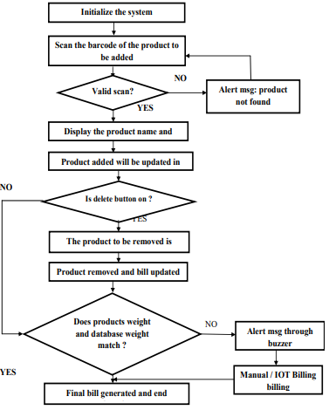
Fig 1.1 Flow Chart of smart cart
  - Hardware and Software tools used
Hardware Tools:-
Sl.No | Component Name | Specification | Quantity
1 | Node MCU | ESP8266 | 1
2 | Load Cell | CZL601 (5–60 kg) | 1
3 | Camera | ESP32(OV2640) | 1
4 | Lipo Rechargeable Battery | 3.7V,400mAH | 1
5 | Bar code reader with camera | Wireless Smart device | 1
6 | Load Cell Amplifier Module | HX711 | 1

Software Tools:-
- Ardiuno Ide
- MySQL
- MIT App Inventor
- Proteus Professional
- Microsoft Visual Studio

Chapter 2
2.BASIC Theory
The entire system is composed of two subsystems:
- The smart cart database system
- The smart cart feedback system
Figure 2.1 shows the design of the smart cart database system, which utilizes bar code scanner, the sensing element of the subsystem, that takes bar codes of different commodities as input to the system, checks in for the commodities into the database, further adding/removing it to the cart system. Following each scan, the data are directed to the cloud, revising the inventory. This smart cart will keep updating the restocking process so that no product is off the shelf. It will also lead customers to the location of their preferred products and assist them on the basis of their earlier purchases. The same smart cart will keep customers informed about their billing amount to aid them to make further purchase decisions. A customer shall contain his/her own login ID and password. The smart cart not only eases the work at the store but also adds technological aspects to a store
Figure 2.2 shows the block diagram of the smart cart feedback subsystem which is a combination of both weight sensing unit and product imaging unit particularly added to make a flawless exemplary system. The customer may face contrarieties such as product not being scanned properly and added to the cart, product being scanned but not added to the cart, products with same weight but different price, and product description being added to the cart. Additionally, there may be instances where the customer attempts scanning of a single product but adds several products into the cart or attempts where high-priced commodity is placed into the cart, scanning the bar code of a low-priced commodity. Thus, feedback system ensures the error-free and theft-free supermarket in absence of manual security.
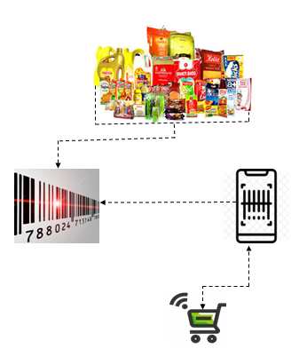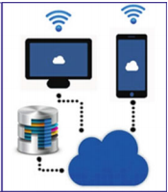
Fig.2.1 Design for the smart cart database system
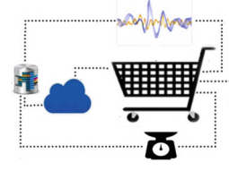
Fig 2.2 Block diagram of the smart cart feedback system
2.1 Product Imaging:- Product imaging takes a real-time feed of the top layer of the smart cart all the time and cross verifies the products visible with the scanned products. In case if any additional item comes into picture which has not been scanned previously, the cart is locked and is not functional to the customer. Also, the owner is informed about the same. This is achieved by means of scale invariant feature transform (ORB) algorithm which acts as a product tracking mechanism for the cart. Based on the comparison between database images and the real-time images taken by an arbitrary camera, a match score is generated which when less than a particular value signifies that the object is not present in the cart and is scanned by the customer. The loopholes present in the system can be nullified by the above load cell weighing mechanism implemented in the cart. As such, both these feedback systems together eliminate the chance of any discrepancy.
2.2 Item-to-Item Based Collaborative Filtering:- Item-item collaborative filtering is one kind of recommendation method which looks for similar items based on the items users have already liked or positively interacted with. It was developed by Amazon in 1998 and plays a great role in Amazon’s success. it suggests an item based on items the user has previously consumed. It looks for the items the user has consumed then it finds other items similar to consumed items and recommends accordingly.
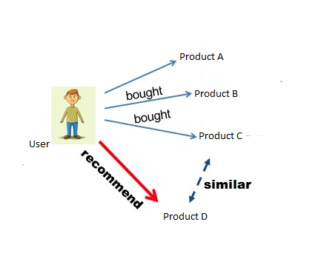.
Fig 2.3 IBCF
Suppose our user wants to purchase a product. Our job is to recommend him a product based on his past preferences. We will first search for products that have been bought or liked, let’s call those products ‘A’, ‘B’ and ‘C’. Next, we will search for other products similar to three products. Suppose we found out that product ‘D’ is highly similar to ‘C’, therefore, there is a highly likely chance that will also like product ‘D’ because it is similar to one has already liked. Hence, we will suggest the product ‘D’ to user
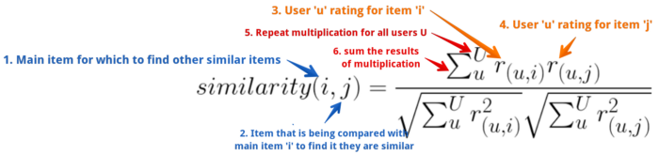
Fig 2.4 Cosine similarity equation
In Fig 2.4 Starting from label 1 (blue on left), above illustrates that in order to calculate the similarity between an item ‘i’ and an item ‘j’ (consider ‘i’ and ‘j’ as product id 1 and 2) multiple all ratings of item ‘i’ and ‘j’ given by users ‘u’ and sum them. Divided the result with the product of square root of the sum of squared ratings of individual items given by user ‘u’. Cosine similarity works but it doesn’t take into account the optimistic behaviour of users. Different users can rate the same item differently depending upon how optimistic they are. On the scale of 5, one could rate an item 5 while another could rate 3 even though they both very much liked the item.
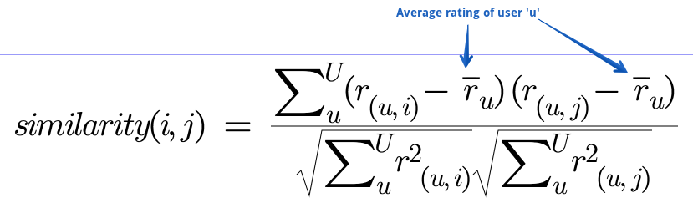
Fig 2.5 Adjusted cosine similarity equation
To account for this we have to make a small change to our similarity formula. Here is what it looks like in Fig 2.5 where subtracting user rating of a given item with that user’s average rating normalizes ratings to the same scale and helps overcome optimism issues. We call it adjusted cosine similarity
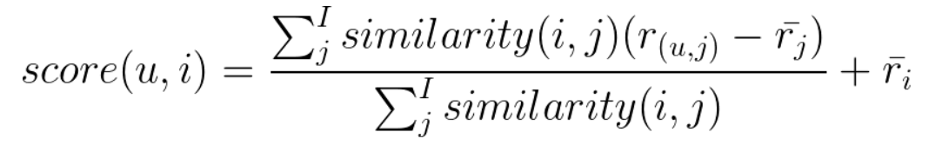
Fig 2.6 Item-Item Based Recommendation System Equation
In Fig 2.6 where, u=user for which we are generating recommendation
i=item in consideration i.e if this item should recommend or not
score (u,i)=generate a score that will indicate how strong a recommendation of item ‘I’ is to our user ‘u’
j=items similar to main item i
In Fig 2.6 equation elicits that in order to calculate recommendation score of an item ‘i’ for a user ‘u’ sum the multiplication of an item ‘i’ and ‘j’ similarity with the difference of rating given by user ‘u’ to an item ‘j’ and the average rating of an item ‘j’. Divide the result with the sum of item ‘i’ and ‘j’s similarity, add the output with the user’s average rating. Doing so will generate a matrix of scores for users and available items. Top scored items can be recommended to the user

Chapter 3
3. Tool Description
- NODE MCU ESP8266:- A low cost and highly integrated solution to connect wirelesss, this micro controller is powered by a 32-bit Ten silica Microprocessor, which makes it possible for it to consume minimum battery resources. The Wi-Fi stack, as well as the Real Time Operating System, allows the user to use 80% of the power for program processing and application development. It is a highly durable, compact and is able to operate for long hours on a single battery, making it suitable for a portable device like a smart supermarket trolley.

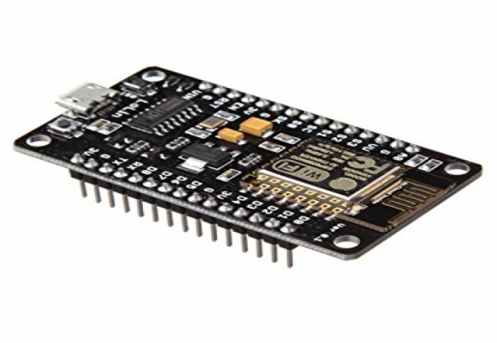
Fig 3.1 NODE MCU ESP8266 Wi-Fi Development Board
- Load cell:- A load cell is a transducer which is used to create an electrical signal whose magnitude is directly proportional to the force being measured. The load cell is the heart of any weighing machine or electric scales. This type of transducer is highly accurate which provides the user with the required information. Strain gauge load cells work on the principle that the strain gauge (a planar resistor) deforms when the material of the load cells deforms appropriately. Deformation of the strain gauge changes its electrical resistance, by an amount that is proportional to the strain. The change in resistance of the strain gauge provides an electrical value change that is calibrated to the load placed on the load cell.

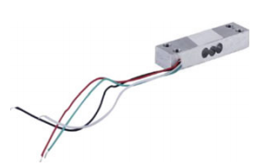
Fig 3.2 Load cell CZL601
- Camera:-ESP32-CAM is a development board module with a size of 27×40mm. It can be integrated into a camera system with an ESP32 module and camera. ESP32-CAM can be widely used in various IoT applications. It is suitable for home smart devices, industrial wireless control, wireless monitoring, QR wireless identification, wireless positioning system signals and other IoT applications. It is an ideal solution for IoT applications.
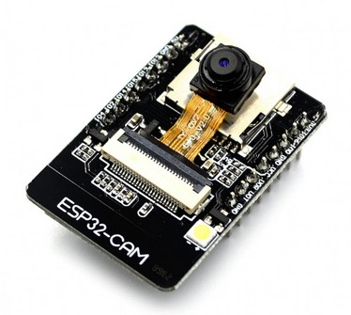
Fig 3.3 ESP32 CAM

- Lipo Rechargeable Battery:-A lithium polymer battery or more correctly lithium-ion polymer battery. It is rechargeable battery of lithium ion technology using a polymer electrolyte instead of a liquid electrolyte. High conductivity semi solid polymers form this electrolyte. These batteries provide higher specific energy than other lithium battery types and are used in applications where weight is a critical feature, such as mobile devices, radio-controlled aircraft and some electric vehicles.
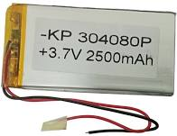
Fig 3.4 Lipo Rechargeable Battery

- Bar code Reader with Camera:-Bar code reader with camera A bar code reader is an electronic device that can read and output printed bar codes to a computer. It consists of a light source, a lens and a light sensor translating optical impulses into electrical ones. Additionally, nearly all bar code readers contain decoder circuitry analyzing the barcode’s image data provided by the sensor and sending the barcode’s content to the scanner’s output port. A standard barcode scanner shines LED or laser light across a barcode, and the beam is reflected back into a light detecting photoelectric cell. The resulting pattern of impulses corresponding to the black and white stripes is converted into respective decimal numbers. After acquiring an image, a digital camera sends it to the software. Here, a program pre-processes the image to prepare it for further analysis. This stage usually includes converting to Grayscale and applying various filters to reduce image noise and enhance bar code edges. After that, a binary operation is performed, which means that only black and white pixels remain in the image. The decoding process consists of two major steps: the location and decoding of the bar code as such.

- Load Cell Amplifier Module:-- HX711 load cell amplifier module uses 24 high-precision A/D converter chip hx711, is designed for high-precision electronic scale and design, with two analog input channels, the internal programmable gain amplify integrated multiplier 128. The HX711 uses a two-wire interface (clock and data) for communication. The input circuit can be configured to provide a bridge type pressure bridge (such as pressure, weighing sensor mode) which is of high precision.

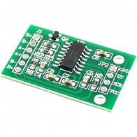
Fig 3.5 HX711 Weighing Module
- Ardiuno Ide:-The arduino integrated development environment is a cross-platform application that is written in functions from c and c++.it is used to write and upload programs to arduino compatible boards, but also with help of third party cores, others vendor development boards.

- MySQL :-A relational database organizes data into one or more data tables in which data types may be related to each other these relations help structure the data. SQL is a language programmers use to create, modify and extract data from the relational database, as well as control user access to the database. In addition to relational databases and SQL, an RDBMS like MySQL works with an operating system to implement a relational database in a computer's storage system, manages users, allows for network access and facilitates testing database integrity and creation of backups.

- MIT App Inventor :-MIT App Inventor is a web application integrated development environment originally provided by Goggle, and now maintained by the Massachusetts Institute of Technology (MIT). It allows newcomers to computer programming to create application software(apps) for two operating systems (OS): Android, and iOS

- Proteus Professional :-Proteus is a Virtual System Modelling and circuit simulation application. The suite combines mixed mode SPICE circuit simulation, animated components and microprocessor models to facilitate co-simulation of complete micro-controller based designs. Proteus also has the ability to simulate the interaction between software running on a micro-controller and any analog or digital electronics connected to it. It simulates Input / Output ports, interrupts, timers, USART and all other peripherals present on each supported processor.

- Microsoft Visual Studio:-Microsoft Visual Studio is an integrated development environment (IDE) from Microsoft. It is used to develop computer programs, as well as websites, web apps, web services and mobile apps. Visual Studio uses Microsoft software development platforms such as Windows API, Windows Forms, Windows Presentation FoundationWindows Store and Microsoft Silverlight. It can produce both native code and managed code. Visual Studio includes a code editor supporting IntelliSense as well as code refactoring. The integrated debugger works both as a source-level debugger and a machine-level debugger. Other built-in tools include a code profiler, designer for building GUI applications, web designer, class designer, and database schema designer. It accepts plug-ins that expand the functionality at almost every level—including adding support for source control systems and adding new tool sets like editors and visual designers for domain-specific languages or tool sets for other aspects of the software development lifecycle (like the Azure DevOps client.

- Product Imaging:- Product imaging takes a real-time feed of the top layer of the smart cart all the time and cross verifies the products visible with the scanned products. In case if any additional item comes into picture which has not been scanned previously, the cart is locked and is not functional to the customer. Also, the owner is informed about the same. This is achieved by means of scale invariant feature transform (ORB) algorithm which acts as a product tracking mechanism for the cart. Based on the comparison between database images and the real-time images taken by an arbitrary camera, a match score is generated which when less than a particular value signifies that the object is not present in the cart and is scanned by the customer. The loopholes present in the system can be nullified by the above load cell weighing mechanism implemented in the cart. As such, both these feedback systems together eliminate the chance of any discrepancy.

CHAPTER 4
4.IMPLEMENTATION
4.1HARDAWARE DESIGN AND IMPLEMENTATION
4.1.1 Load Cell and HX711 Connections:-
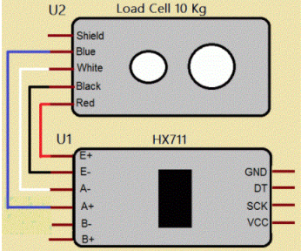
Fig 4.1 Load cell and HX711 Connections
RED wire is connected to E+
BLACK wire is connected to E-
WHITE wire is connected to A-
BLUE wire is connected to A+
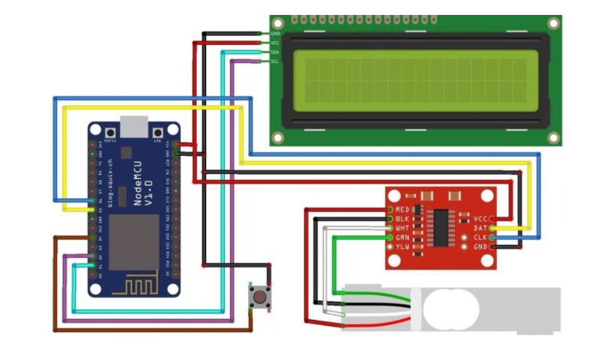
Fig 4.2 Circuit diagram for interfacing 40KG Load Cell and HX711 Module with NodeMCU ESP8266 12E Board.
The connection between Load Cell & HX711 has been explained above. Connect the DT & SCK Pins of Load Cell to ESP8266 D5 & D6 Pins respectively. We have used a push-button tact switch to reset the weight to zero. Push-button Switch is a connected digital pin D4 of ESP8266. I used a 16X2 I2C LCD Display to minimize the connection. So, connect the SDA & SCL pin of I2C LCD Display to D2 & D1 of Nodemcu respectively.

4.1.2 NodeMCU Programming
The Arduino Integrated Development Environment - or Arduino Software (IDE) – to program the NodeMCU. This IDE contains An Editor, Text area ,Text Console,A toolbar with common facilities,Menus.
It interfaces with the Node-MCU equipment to transfer programs and speak with them. Projects composed utilizing Arduino Software (IDE) are called draws. These portrayals are composed in the content tool and are spared with the record extension. The editorial manager has highlights for cutting/gluing and for looking/supplanting content. The message range gives input while sparing and sending out and shows mistakes. The comfort shows content yield by the Arduino Software (IDE), including complete blunder messages and other data. The base right-hand corner of the window shows the designed board and serial port. The toolbar catches enable you to confirm and transfer programs, make, open, and spare portrays, and open the serial screen.
Pseudo code for the NodeMCU Firmware
Include the Wi-Fi and Serial Port Header File
Define SSID and Password values for Wi-Fi Connection
Setting up the static IP Address for the Node-MCU, so that every time we get the same IP address Setup a Software Serial Port to communicate to the Weight Sensor
Define the GPIO pins used for Led and Beeper

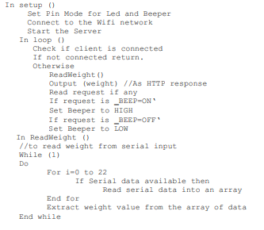
Fig 4.3 Pseudo code for the NodeMCU Firmware

4. Software Algorithm and Implementation
Mobile App Design:-

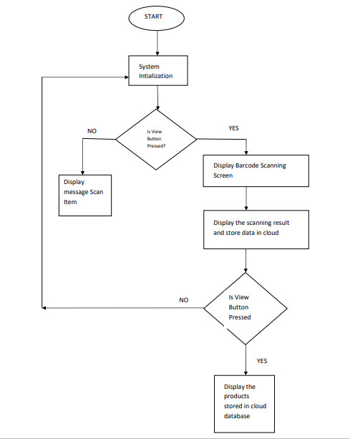
Fig 4.3 Flow chart of working of App

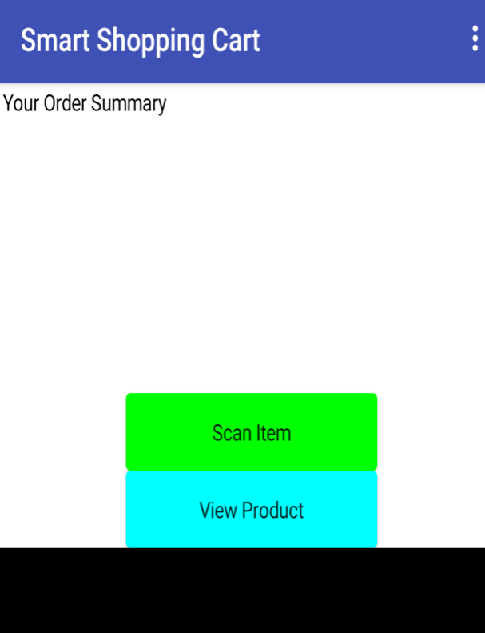
Fig 4.4 Home page of the app
Product Imaging Simulation Results using ORB Algorithm:-

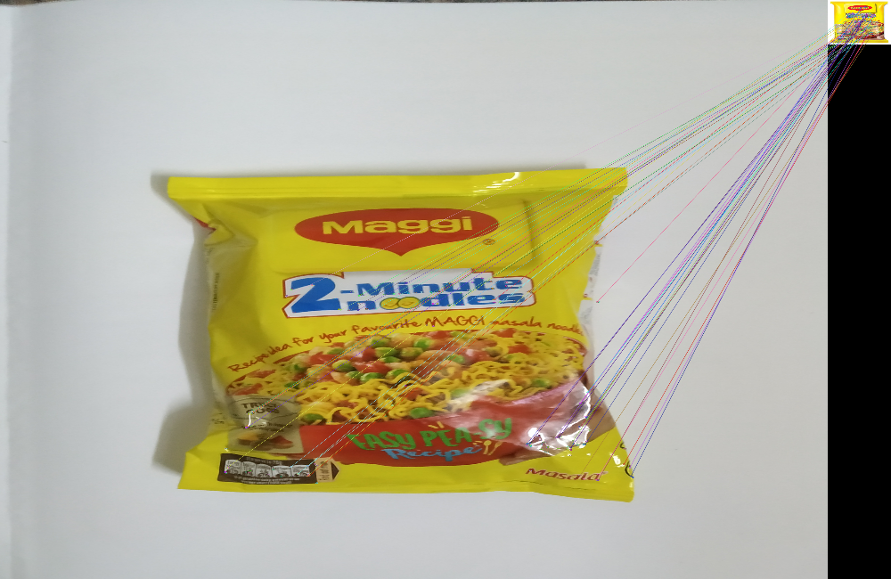

Fig 4.5 ORB Algorithm Implementation results
Chapter 5
5. RESULTS AND Discussion
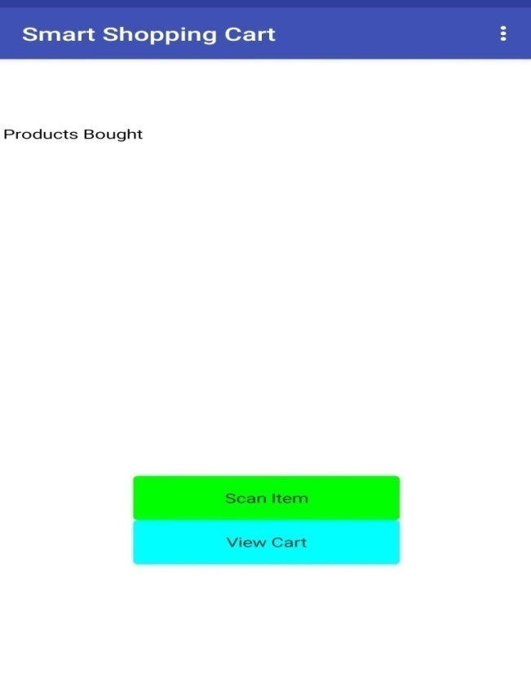
Fig 5.1 Home mode screen
Fig 5.1 shows the design of the smart shopping cart app, which utilizes bar code scanner as the sensing element of the subsystem that takes bar codes of different commodities as input to the system.
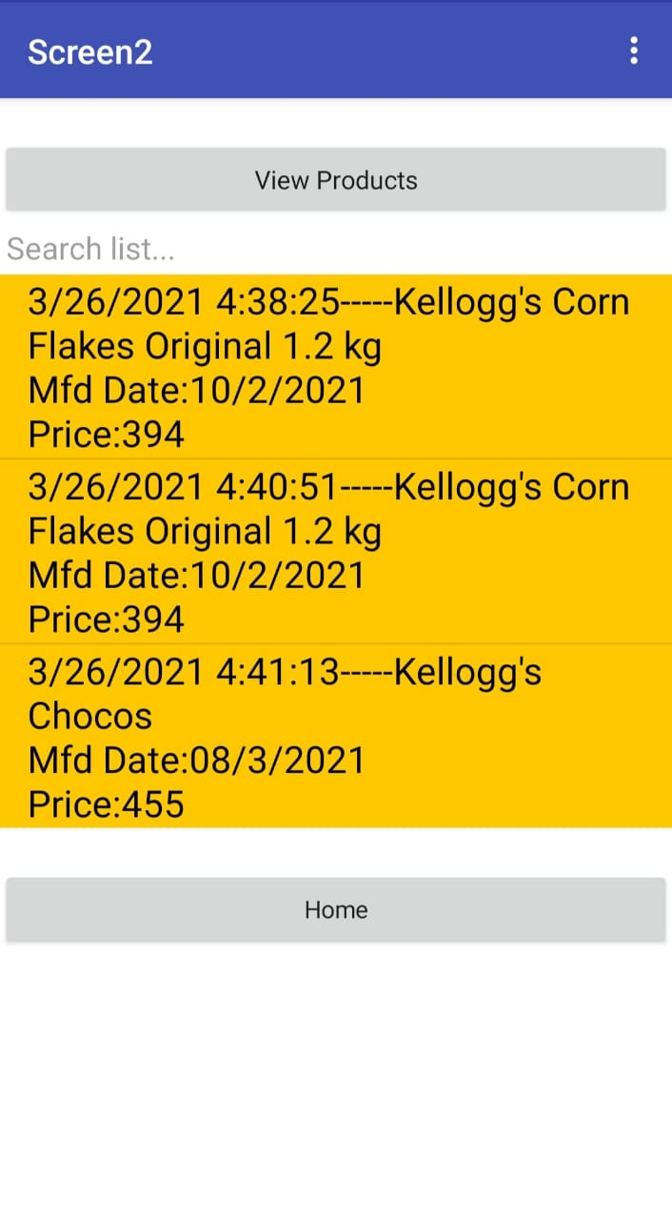
Fig 5.2 Product list from the database
In fig 5.2 when a user clicks on the scan button it directs it to barcode scanner allowing the user to scan their desired product and description of these products is shown in the products bought section, Following each scan the data is being revised in the inventory. This app will keep updating the restocking process so that no product is off the shelf. In fig 5.2 view cart button will keep customers informed about their billing amount to aid them to make further purchase decisions. The Recommend button in the app recommend products to the user based upon their present and past purchasing behaviour .

Fig 5.3 Product Imaging
In fig 5.3 takes a real-time feed of the top layer of the smart cart all the time and cross verifies the products visible with the scanned products. In case if any additional item comes into picture which has not been scanned previously the cart gets locked and it is not functional to the customer. This is achieved by means of scale invariant feature transform (ORB) algorithm which acts as a product tracking mechanism for the cart. The loopholes present in the system can be nullified by the above product imaging mechanism being implemented in the cart
MYSQL provides a facility to store data up to a certain extent. If one needs facility on the cloud and needs to analyse data further, advanced data analytic software can be used. The application developed for the smart shopping cart will facilitates the owner showing him the daily stock, alarming him when a product is off shelf and needs immediate restocking and it also provides customer to scan the bar codes of their desired product and also view the products which they purchased .Product Imaging using ORB algorithm has been implemented to eliminate the thefts and to minimize the losses that occurred to the owner due to the theft activities.
The application developed for the IoT based smart shopping cart will eliminate the cost of deploying contemporary bar code scanners and the cost incurred for its maintenance and as well as the investment in customized central hardware. The synchronization latency ,royalty fees, less accuracy occurred due to the SIFT algorithm has been improved with the implementation ORB algorithm which yields better results compared to the previous algorithm.

CONCLUSIONS AND FUTURESCOPE
In this proposed system, the successful use of the NodeMCU system for the Iot based smart shopping cart has been explained. The drawbacks addressed in previous smart cart applications has been overcome in this application .Project implementation will help people who are shopping in the supermarkets and eliminate standing in a long queue for final billing. The implementation is easy and very economical and will reduce the time required at the billing counter .In our proposed project, we designed IoT based smart shopping cart for the billing system which can be used in any supermarket and by any person easily and act as a self-checkout system providing users with the flexibility to make transactions from it within the retail store. It is designed to be highly efficient and fully synchronized with the retailer’s current system. The future scope includes adding more computation at the cloud end. Implementation such a system in retail shall bring sown labour dependency,easy management at the owner’s end and in turn will improve the pre and post-shopping experience

REFERENCES

APPENDIX –I
SOURCE CODE
Product Imaging Simulation Code
#Algorithm
#Take the query image and convert it to greyscale.
#Now Initialize the ORB detector and detect the key points in query image and scene.
#Compute the descriptors belonging to both the images.
#Match the key points using Brute Force Matcher.
#Show the matched images.
import numpy as np
import cv2
from google.colab.patches import cv2_imshow
# Read the query image as query_img
# and traing image This query image
# is what you need to find in train image
# Save it in the same directory # with the name image.jpg
query_img=cv2.imread('/content/drive/MyDrive/Images_for_ORB/query_img_bw.jpg')
train_img=cv2.imread('/content/drive/MyDrive/Images_for_ORB/train_image_bw.jpg')
# Convert it to grayscale
query_img_bw = cv2.cvtColor(query_img,cv2.COLOR_BGR2GRAY)
train_img_bw = cv2.cvtColor(train_img, cv2.COLOR_BGR2GRAY)
# Initialize the ORB detector algorithm
orb = cv2.ORB_create()
# Now detect the keypoints and compute
# the descriptors for the query image
# and train image
queryKeypoints, queryDescriptors=orb.detectAndCompute(query_img_bw,None)
trainKeypoints, trainDescriptors = orb.detectAndCompute(train_img_bw,None)
# Initialize the Matcher for matching
# the keypoints and then match the
# keypoints
matcher = cv2.BFMatcher()
matches = matcher.match(queryDescriptors,trainDescriptors)
# draw the matches to the final image
# containing both the images the drawMatches()
# function takes both images and keypoints
# and outputs the matched query image with # its train image
final_img = cv2.drawMatches(query_img, queryKeypoints,
train_img, trainKeypoints, matches[:20],None)
final_img = cv2.resize(final_img, (1000,650))
# Show the final image
cv2_imshow(final_img)
cv2.waitKey(3000)
Item-Item Based Collbrative Filtering Code:
import pandas as pd
from scipy import sparse
from sklearn.metrics.pairwise import cosine_similarity
ratings=pd.read_csv("dataset.csv",index_col=0)
ratings.fillna(0, inplace=True)
Ratings
def standardize(row):
new_row = (row - row.mean())/(row.max()-row.min())
return new_row
df_std = ratings.apply(standardize).
T print(df_std)
sparse_df=sparse.csr_matrix(df_std.values)
corrMatrix=pd.DataFrame(cosine_similarity(sparse_df),index=ratings.columns,columns=ratings. CorrMatrix
corrMatrix = ratings.corr(method='pearson')
corrMatrix.head(6)
items = [("Milk",5),(" Rice flour ",1),("Jaggery",1)]
similar_scores = pd.DataFrame()
for products,rating in items:
similar_scores=similar_scores.append(get_similar(products,rating),ignore_index = True)
similar_scores.head(10)
similar_scores.sum().sort_values(ascending=False)

DETAILS OF PAPER PUBLICATION
- V. N. Prithvish, Shraddha Agrawal and John Sahaya Rani Alex An IoT-Based Smart Shopping Cart Using the Contemporary Bar-code Scanner 2018
- Ankush Yewatkar, Faiz Inamdar, Raj Singh, Ayushya, Amol Bandale. Smart Cart with Automatic Billing, Product Information, Product Recommendation Using RFID & Zigbee with Anti-Theft. International Conference on Communication, Computing and Virtualization, 2016, 793 - 800
- G.S.Rajagopal, Mr.S.Grout, Prof. M.Janarthanan. Smart Intelligent System for Shopping and Billing. International Journal of Advanced Research Trends in Engineering and Technology, Vol. 3, Issue 19, April 2016, 339-343
- Anjali Verma, Namit Gupta. RFID based Smart Multitasking Shopping Trolley System. International Journal for Scientific Research & Development, Vol. 3, Issue 06, 2015, 1389-1392.
- Ms.Vrinda, Niharika, Novel Model for Automating Purchases using Intelligent Cart, e-ISSN: 2278-0661, pISSN: 1; 2278- 8727Vol- ume16, Issue 1, Ver. VII (Feb. 2014), PP 23-30
- Budic D, Martinovic Z, Simunic D, Cash register lines optimization system using RFID technology, IEEE Explore, 2014.
- Chandrasekar P, Sangeetha T (2014) Smart shopping cart with automatic billing system through RFID and ZigBee. IEEE. ISBN: 978-1-4799-3834-6/14

INFORMATION REGARDING STUDENT

Batch Photograph Along With Guide


Prof.Basavaraj.H
Assistant Professor
Department of Electronics and Communication Engineering
Faculty of Engineering & Technology
JAIN(DEEMED-TO-BE UNIVERSITY)


AKHILESH SHINDHE VIJAYKUMAR S RAYANAGOUDAR
17BTLEC002 17BTLEC008


RAHUL RAO SHINDE K ANISH KUMAR SINGH
17BTLEC012 17BTREC017

